Tutorial
How to approve and reject pages

This document describes how to approve or reject pages using the Apogee Portal WebApproval system.

1. Introduction

1. Direct vs multi-step approval

Depending on the license you have, you can choose between direct or multi-step approval. This is a configuration parameter for the created job.
- Direct approval
When a page is approved by one user/approver, it will be treated as approved.
- Multi-step approval
All users must approve the page before it is considered approved.
When the user/approver rejects a page, it will be rejected for all users.

2. Final approval
Final approval is a way to make the final decision to send pages to production.

The printing house may indicate one or more persons responsible for the final approval of the job. From this point on, approvers confirm the correctness of the pages, which in the last stage will have to obtain the final approval of the selected person in order to be sent to production.

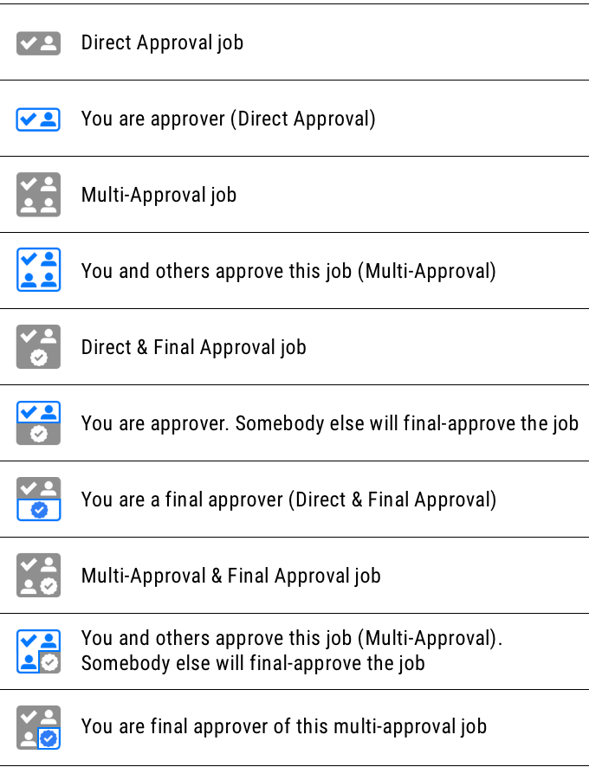
3. Job icons
Each job contains an approval icon according
to the table on the right.
The icon suggests what the user should do in a
given task. If the icon is gray, the user has not
been assigned a special role in the given task.
If a role is assigned, the icon will be partially
marked in blue. The description in the bubble
that appears when you point to the icon
contains more information.

4. Approval icons
To indicate the difference between direct and multi-step approval, the icons inform about the approval status.
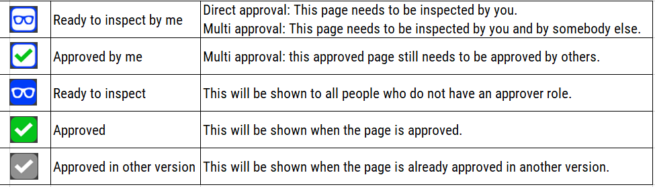

2. Verification
To open the job for review, click the link in the received email that indicates that some or all of the pages of the work are ready for review. Clicking the link opens the job in the book view. You can also log in to the WebApproval Portal, open the work window in list or tile view, and then click the job you want to check and approve.
- In the tile view, check the approval icon (1) to make sure that you have the appropriate approval rights and then click the information icon (2) to see how many pages are available for review (3).
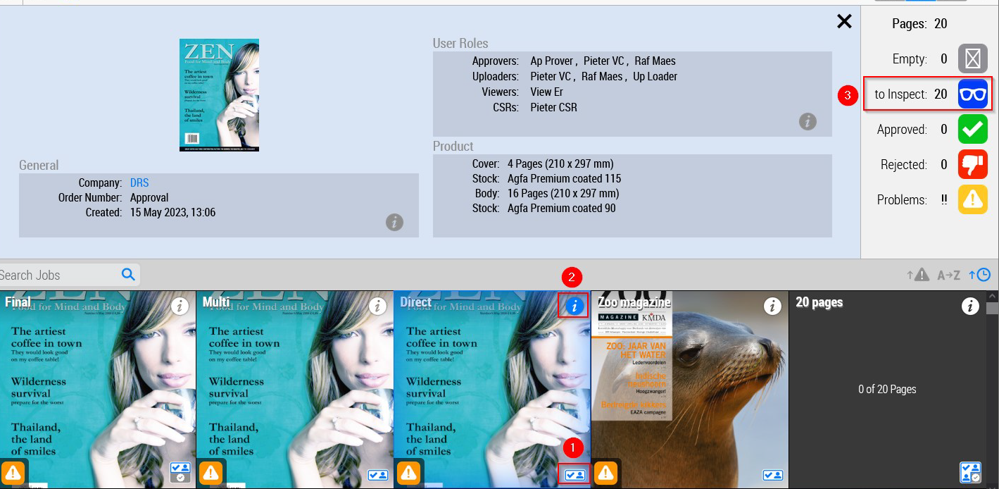

- In the list view you can see both information: the approval icon (4) and the number of pages to be approved (5).
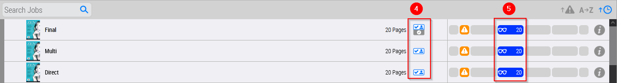

3. Approval or rejection of pages in the book review
After opening a job by clicking a tile or a work on the list you will be transferred to the book or page review depending on which view was used previously. You can start approving/rejecting pages.

1. Approval/ rejection/ quick approval in the action panel
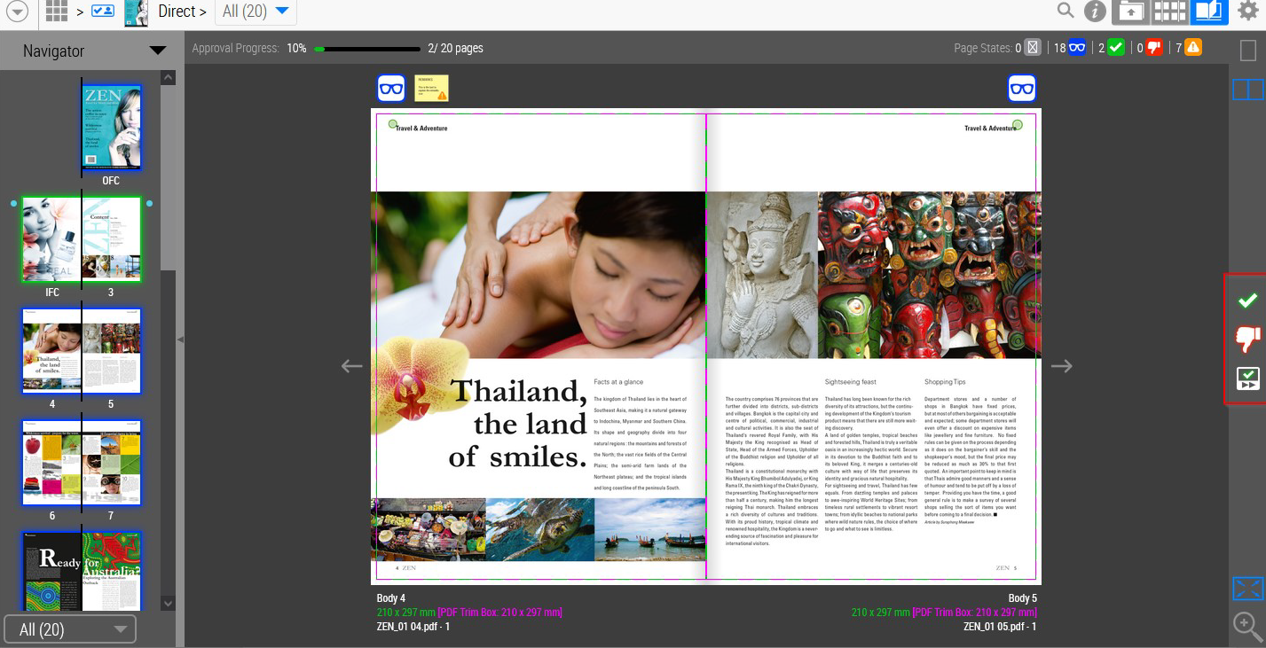


1. Go to the page or double-page spread that you want to approve/reject.

2. Click on the icon „approve”

or „reject”.

A window will appear in which you can approve or reject the two pages (when using the spread view). Please note that you can disable the page that should not be accepted/rejected.
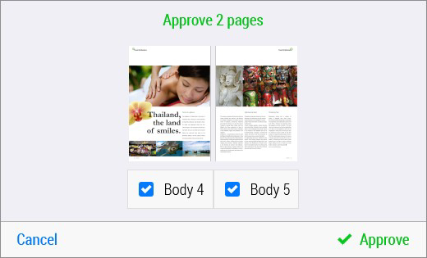
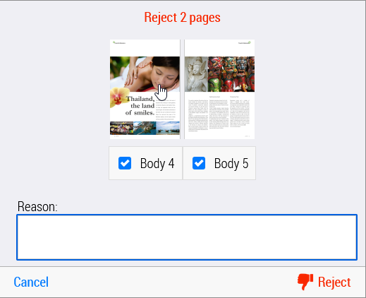

3. You can click „approve” to approve the pages. In case of rejection, you should first provide a reason and then click the icon „reject”.


Approved pages will be marked with the icon „approved”: , and rejected pages with the icon „rejected” and a red diagonal strikethrough. In the navigation window, approved pages will have a green framing, while rejected pages will have a red framing and a red strikethrough.
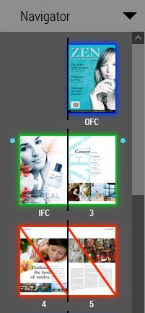


4. You can also use the „quick approval” icon to approve a page or a double-page spread. This will approve the current page or spread (without asking for confirmation) and transfer you to the next page or spread which is ready for review.
The icon for the quick approval is blue when the page or the double-page spread can’t be approved.


At the top of the book view, you can press the A key to show or hide the approval progress bar.
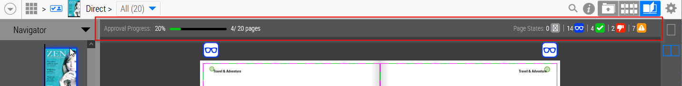

Approving/Rejecting from the Action Menu
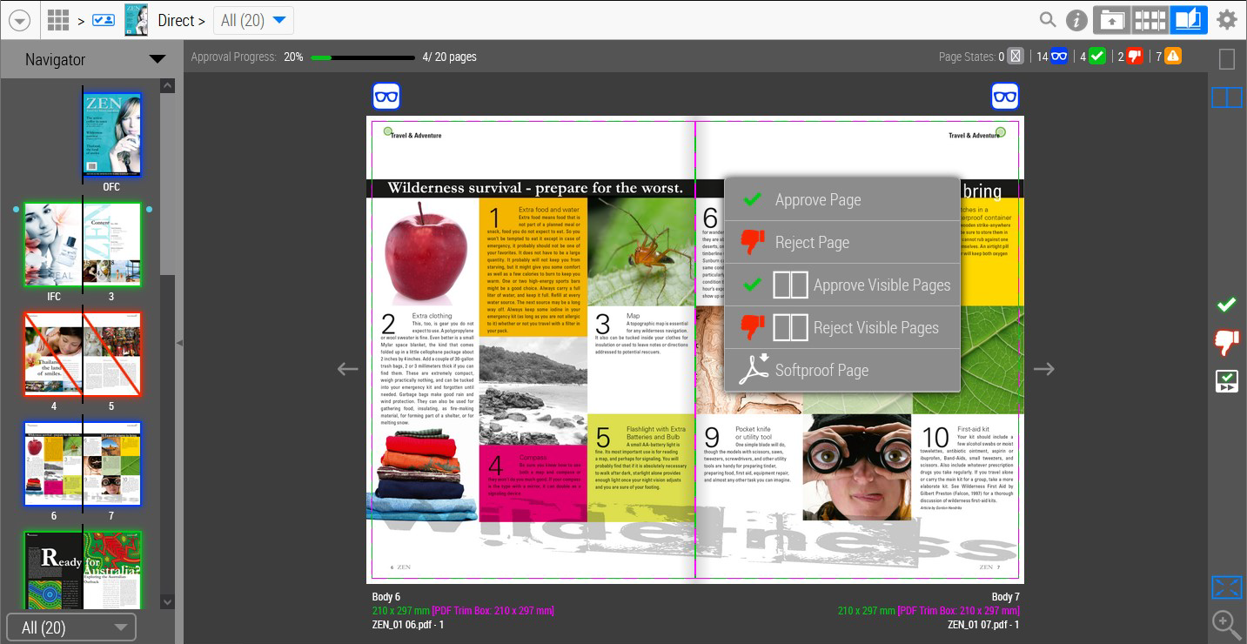

- Go to the page or spread you want to approve or reject.
- Right-click to open the action menu.
- Select Approve/Reject Page or Approve/Reject Visible Pages to approve or reject.
Note that no confirmation window will appear; however, you will still be required to provide a reason when rejecting.
Accept all remaining pages
- If you don’t want to approve each page individually, you can review all pages in the project (while in the book view), then click the gear icon and select the Accept All Remaining Pages option.
2. Click on „approve” to confirm the approval.

4. Approving or rejecting pages in the page view
1. Approving / rejecting from the action panel
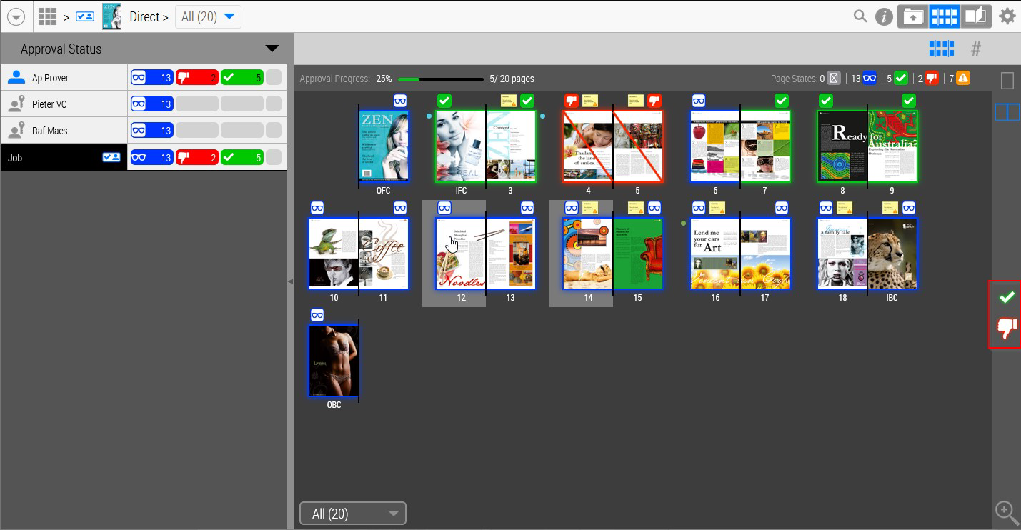



1. Select one or more pages to activate the icons „approve” or „reject” . If no pages are selected, the icons will be grayed out.

Click the icon „approve” or „reject”. A confirmation window will appear.
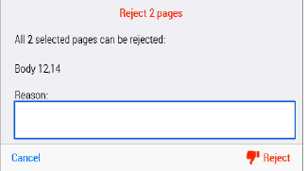
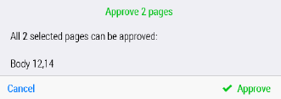



3. You can click „approve” to approve the pages. In case of rejection, you must provide a reason and then click „reject”.
Accepted pages will be marked with a green icon , while rejected pages will be marked with a red icon and a red diagonal line.

2. Approving/Rejecting from the Action Menu
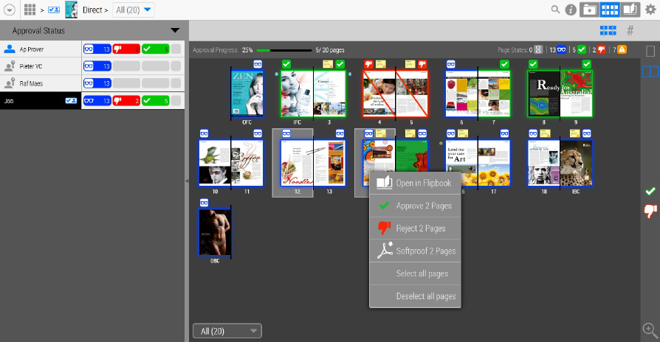

1. Select one or more pages, then right-click to open the action menu.
2. Select Approve/Reject x pages to approve or reject them.
A confirmation window will appear.
3. You can click Approve to approve the pages. In case of rejection, you must provide a reason and then click Reject.

3. Approve all remaining pages

1. You can also choose to approve all remaining pages by clicking the gear icon and selecting Accept All Remaining Pages.

2. Click Approve to confirm the approval.

5. Special Cases
- Approving of rejected pages
If the option "Approver can accept rejected pages" is enabled for your company, the approver will be able to approve pages that were previously rejected. If this option is disabled, a new file must be uploaded to replace the rejected page, which can then be approved. Alternatively, you can contact the print shop and request approval of the rejected page.
- Rejecting of approved pages
Approved pages are ready for printing or may already be printed. Therefore, the approver will not be able to reject a previously approved page. This action can only be done by a print shop staff member. If you need to reject an already approved page, you should contact the print shop.
- Approval/Rejection in Jobs with Versions
1. Select the version you want to approve or reject

- by clicking the dropdown field with versions located in the top panel of the book view or page view
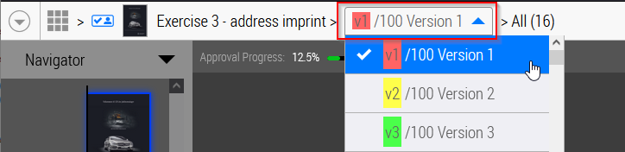

- choose the version from the list of the versions
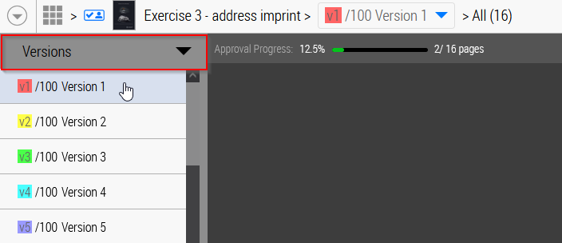

- choose the version from the list of the jobs

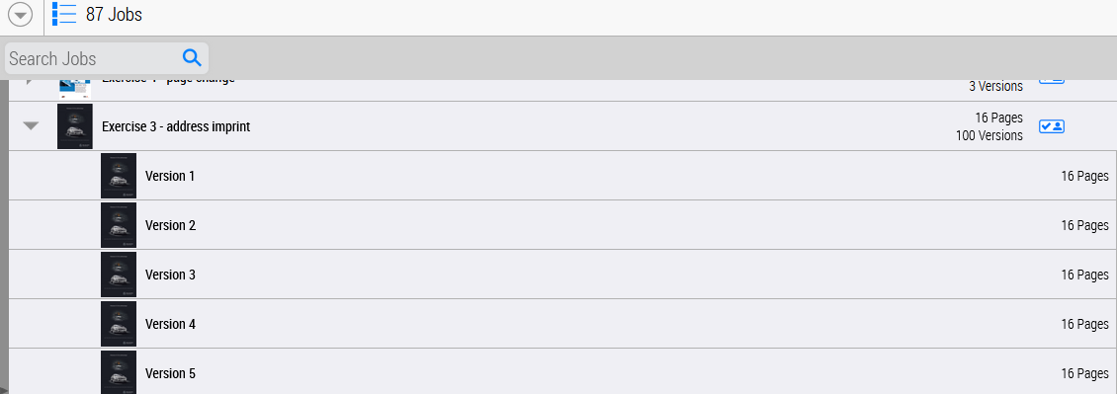

2. Approve or reject pages using the icons in the action menu.
3. Depending on the settings for a version you will be able to approve or reject pages for the chosen version or you will be able to mark a field and then approve / reject pages in the remaining versions.
